13.45: The period of the pendulum is 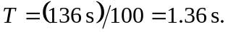Then,
